S-100 – Part 10b

GML Data Format
Summary of Substantive Changes in Edition 5.2.0

Change Summary | Clauses Effected
Part 10b – GML Data Format

Contents

10b-1 Scope 1
10b-2 Conformance 1
10b-3 References 1
10b-3.1 Non-normative references 2
10b-4 Introduction 2
10b-5 General concepts 2
10b-6 Notation and diagram conventions 2
10b-7 Components and relationships to standards 2
10b-7.1 Use of profile 3
10b-8 Profile for feature data 4
10b-8.1 Feature and information types 4
10b-8.2 Data types 4
10b-8.2.1 Primitive types 4
10b-8.2.2 Extended Value types 4
10b-8.2.3 Attribute types 4
10b-8.2.4 Enumerations 4
10b-8.3 Feature collections 5
10b-8.4 Associations 6
10b-8.4.1 Association classes 6
10b-9 S-100 GML data formats 7
10b-10 Processing of GML datasets 8
10b-10.1 Spatial types 8
10b-10.1.1 Geometric primitives 8
10b-10.1.2 Curve Interpolation 9
10b-10.1.3 Geometric complex, geometric composites, and geometric aggregates 10
10b-10.1.4 Inline and by-reference encoding 10
10b-10.1.5 Envelope 10
10b-10.1.6 Schema elements for spatial attributes 10
10b-10.1.7 Masking, truncation and scale ranges 10
10b-10.2 Unsupported GML functionality 13
10b-10.3 Compliance levels 13
10b-11 S-100 base schema for feature data 14
10b-11.1 Introduction 14
10b-11.1.1 Construction of the xsd header 14
10b-11.2 Feature and information types 15
10b-11.3 Spatial types 16
10b-11.3.1 Inline and referenced geometry 16
10b-11.3.2 Spatial types defined in base schema 16
10b-11.4 Associations 17
10b-11.4.1 Role name as property element 17
10b-11.5 Updating 18
10b-11.6 Dataset general information 18
10b-11.6.1 Dataset identification 18
10b-11.7 Coordinate Reference System 20
10b-11.8 Dataset structure definition 21
10b-11.8.1 Dataset metadata 21
10b-12 Constraints and validation 21
10b-13 Dataset level metadata and integrity checks 21
10b-14 Schema locations and namespaces 21
10b-15 Divergences from common GML practices 21
Appendix 10b-A Application Schema (informative) 23
Appendix 10b-B Use of Profile in GML Application Dataset (informative) 25
10b-B-1 Introduction 25
10b-B-2 Dataset structure in GML application schema 25

Page intentionally left blank

Scope
This Part specifies a profile of GML meant to be used as a basis for the development of GML application schemas for S-100 data products. The GML application schema for each S-100 data product defines a file format for the machine-to-machine exchange of information structured in conformance with the application schema for the data product and matching the content of the Feature Catalogue, as defined in the appropriate Product Specification.
The scope of this Part includes:
- Feature and information type data conforming to the S-100 General Feature Model defined in Part 3, encoded using GML (ISO 19136), and structured as datasets (identifiable collections of data).
- Construction of GML Schemas from Feature Catalogues.
- Guidance for use of the Schemas in Application Schemas for data products.
The following are outside scope:
- A format for updates to datasets.
- Interchange by means other than datasets encapsulated as files, such as Web Feature Service (WFS), other Web services, email, etc.
- Information not encapsulated using GML, such as Feature Catalogues, Exchange Set metadata, Portrayal Catalogues, and support files in other XML formats.
- Tools for developing GML Application Schemas for data products.
- Design and programming of software for processing GML data.
- Gridded and coverage data.

Conformance
The profile described in this Part conforms to the requirements for GML profiles described in ISO 19136.

References
ISO 19106:2003, Geographic information – Profiles
ISO 19107:2003, Geographic information – Spatial schema
ISO 19111:2007, Spatial referencing by coordinates (coordinate reference systems)
ISO 19118:2005, Geographic information – Encoding
ISO 19123:2005, Schema for coverage geometry and functions
ISO 19136:2007, Geographic information – Geography Markup Language
ISO 19136-2:2015, Geographic information – Geography Markup Language
ISO/TS 19139, Geographic information – Metadata – XML schema implementation
ISO/IEC 19757-3, Information technology – Document Schema Definition Languages (DSDL) – Part 3: Rule-based validation – Schematron
IETF RFC 2396, Uniform Resource Identifiers (URI): Generic Syntax
IETF RFC 3986, Uniform Resource Identifiers (URI): Generic Syntax
W3C XLink, XML Linking Language (XLink) Version 1.0, W3C Recommendation
W3C XML Namespaces, Namespaces in XML, W3C Recommendation
W3C XML, Extensible Markup Language (XML) 1.0, W3C Recommendation
W3C XML Schema Part 1, Structures, W3C Recommendation
W3C XML Schema Part 2, Datatypes, W3C Recommendation
LEIRI, Legacy Extended IRIs for XML Resource Identification, W3C Working Group Note 3. URL: http://www.w3.org/TR/leiri

Non-normative references
The following references are listed only for informative purposes or to clarify parts of this document. Drafts are subject to change and are not international standards.
ISO/DIS 19107, Geographic information – Spatial schema (Draft – June 2018)

Introduction
The S-100 GML profile defines the core GML components that shall be used in GML encodings for S-100 data products. This profile defines a restricted subset of XML and GML types that excludes GML features not required by S-100 GML datasets. The profile of GML is contained in multiple Schema files and reduces the complexity of the full GML encoding to a more manageable level. Part of the Schema defines common elements and types needed for all S-100 datasets encoding feature-based information.

General concepts
A GML application schema is an XML schema that conforms to the rules for application schemas given in the GML specification (ISO 19136).
A GML document is an XML document with a root element conforming to the rules for GML data specified in the GML specification (ISO 19136). Specifically, in the context of S-100 this means the root element must be a GML AbstractFeature or Dictionary element, or in a substitution group of any of these elements.
The terms “GML application schema” and “application schema” as used in this Part mean respectively an XML schema and a conceptual schema. The former may be an XSD file conforming to the XML schema rules, the latter a UML diagram, conforming to the S-100 Application Schema rules.
These terms and definitions conform to ISO 19101 and ISO 19136. Complete definitions are given in ISO 19101 and ISO 19136, and are reproduced in Annex A.
An S-100 based Feature Catalogue presents the abstraction of reality represented in one or more sets of geographic data as a defined classification of phenomena. It presents a machine-readable description of a Product Specification Conceptual Schema according to S-100 Part 5.

Notation and diagram conventions
Diagram element | Meaning
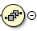 or 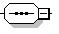 | XML Schema <sequence>
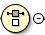 or 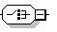 | XML Schema <choice>
 | XML schema multiplicity constraints (here, ”0” and ”unbounded”)

Components and relationships to standards
The GML data encoding for S-100 consists of the following components, realized as separate XML schemas:
- An XML schema that defines a GML profile (“Profile”). This is a restricted subset of types and elements (“XML constructs”) defined in the GML 3.2.1 schemas. XML constructs not needed for S-100 data products are excluded.
- An XML schema defining additional XML constructs (“S100base”). This schema uses the GML profile schema. The constructs defined in this schema are expected to be needed in order for a product specification conforming to the S-100 standard to define a format for datasets.
Figure 10b-1 below illustrates the relationships between the various elements of the S-100 framework, an S-100 product specification and the GML profile. The GML encoding standard (ISO 19136:2007) provides an implementation schema (XML Schema) for the ISO 19100 conceptual schemas. The S-100 GML profile is a subset of the constructs defined by the GML implementation schema. S-100 common elements are defined in a common elements XML schema conforming to the profile. GML formats for specific data products use the constructs in the common elements to define XML types and elements corresponding strictly to feature and information types defined by the relevant Product Specification in the Feature Catalogue. A dataset is an XML file conforming to the GML Application Schema.
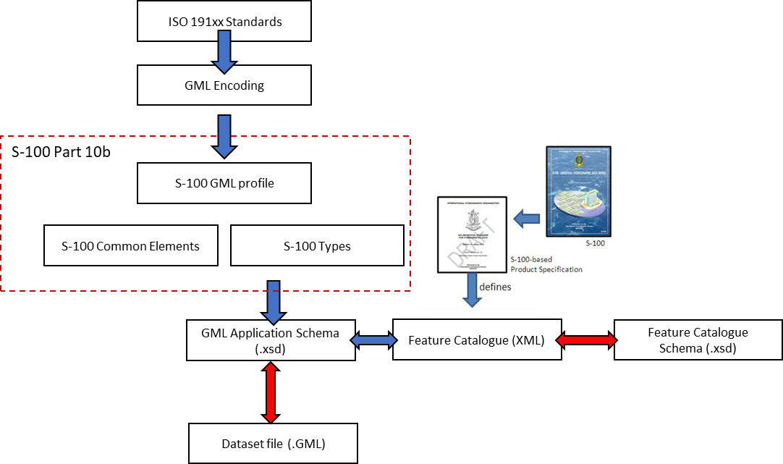
Figure 10b-1 – Derivation of profile and its use by a data product

Use of profile
The typical use of the profile is to define a format for GML files encapsulating datasets packaged as files.
Formats for modes of exchange other than datasets are not required to use these Schemas.
The S-100 GML Profile has been defined to support Schema validation. The S-100 GML Profile must be declared within the Application Schema. This allows a validation engine to select this Schema instead of the GML 3.2.1 Schema to validate the data against.
A GML Application Schema mirrors the feature/attribute names, multiplicities, geometric primitives, types and relationships which are defined in the Feature Catalogue. While Schema validation is possible it should also be possible to unambiguously parse a GML dataset using the Feature Catalogue without recourse to the Application Schema.

Profile for feature data

Feature and information types
The profile supports the ability to encode classes defined as identifiable objects as derived from either the abstract GML type or abstract feature type:
- AbstractGML (shall be used to derive S-100 Information Classes).
- AbstractFeature (shall be used to derive S-100 Feature Classes).
The S-100 GML Profile prohibits the use of the gml:StandardObjectProperties group.

Data types

Primitive types
The S-100 GML Profile supports the types defined in S-100 Feature Catalogues (as defined in S-100 Part 2a, clause 2a-4.2.9) with the following equivalents. Types are supported using XML Schema (“xs:”) built-in data types where possible except as noted.
Table 10b-1 – S-100 primitive types
Feature Catalogue Types | XML / GML Profile Equivalent
boolean | xs:boolean
integer | xs:integer
real | xs:decimal
text | xs:string
date | xs:date
time | xs:time
dateTime | xs:dateTime
S100_TruncatedDate | S100_TruncatedDate
URI, URN, URL | xs:anyURI

All S-100 types referred to in Table 10b-1 are defined within the S-100 GML Profile. The profile also provides common restrictions of types for non-negative Decimals and Decimals in the range 0.0-360.0 (for ° representations).

Extended Value types
The S-100 GML Profile supports the value types defined in Part 1, clause 1-4.5.3.5:
- Measure
- Length
- Angle
NOTE: S100_UnitOfMeasure type shall be realised by the uom property, the value of which should reference to a value defined in a codelist Register which provides the name, definition and symbol.

Attribute types
S-100 simple attributes shall take one of the types defined in Table 10b-1 above. S-100 Complex attributes have no named type in the GFM.
The naming convention for Schema types of simple attributes and complex attributes shall have a defined type name “<Name>Type” where <Name> is the ”code” field defined in the associated Feature Catalogue. The “code” field is expected to be compliant with the xs:NCName criteria.

Enumerations
For S-100 enumeration or S-100 codelist attributes, datasets must use the code and label of the listed value as encoded in the Feature Catalogue.
Enumerations shall be constructed using a combination of restricted simple types for the code and label.
The code simple type shall be a restriction of xs:integer with the list of allowable enumeration codes from the Feature Catalogue. The type name shall be constructed as <Name>Code using the attribute code.
<xs:simpleType name="cardinalDirectionCode">
<xs:restriction base="xs:integer">
<xs:enumeration value="1">
<xs:annotation>
<xs:documentation>N</xs:documentation>
</xs:annotation>
</xs:enumeration>
<xs:enumeration value="2">
<xs:annotation>
<xs:documentation>NNE</xs:documentation>
</xs:annotation>
</xs:enumeration>
…
The label simple type shall be a restriction of xs:string using the allowable enumeration labels from the Feature Catalogue. The type name shall be constructed as <Name>Label using the attribute code.
<xs:simpleType name="cardinalDirectionLabel">
<xs:restriction base="xs:string">
<xs:enumeration value="N">
<xs:annotation>
<xs:documentation>1: north</xs:documentation>
</xs:annotation>
</xs:enumeration>
<xs:enumeration value="NNE">
<xs:annotation>
<xs:documentation>2: northnortheast</xs:documentation>
</xs:annotation>
</xs:enumeration>
…
The enumeration attribute type is defined as a complex type extending from the label type and including the code type as an xml attribute.
<xs:complexType name="cardinalDirectionType">
<xs:annotation>
<xs:documentation>Cardinal direction: Principal and intermediate compass points.</xs:documentation>
</xs:annotation>
<xs:simpleContent>
<xs:extension base="cardinalDirectionLabel">
<xs:attribute name="code" type="cardinalDirectionCode"/>
</xs:extension>
</xs:simpleContent>
</xs:complexType>

Feature collections
A feature collection is a collection of feature instances. Within GML 3.2.1, the generic gml:FeatureCollection element has been deprecated. A feature collection is any feature class with a property element in its content model which is derived by extension from gml:AbstractFeatureMemberType.
The S-100 GML Profile supports the GML 3.2.1 approach to model a Feature Collection class within an S-100 GML Application Schema.
For exchange of file-based GML data using S-100 the GML Profile includes:
- A FeatureCollection, named “Dataset”; and
- Generic dataset metadata types with mandatory dataset metadata elements
Other exchange mechanisms, for example via API mechanisms may wrap GML data encoded in conformance with this part with different feature collection mechanisms.

Associations
The profile allows associations to be encoded inline or by reference. The dataset metadata field associationEncoding shall be defined as either “reference” or “inline” to define which method is used throughout conforming datasets. In addition to the dataset metadata constraint such associations shall only be used to express composition relationships defined by the corresponding Feature Catalogue.
For bi-directional associations, the profile supports the optional encoding of the name of reverse property in the appInfo annotation element in the Application Schema XSD.

Association classes
The profile allows the GML 3.3 convention for encoding of association classes using the GML 3.3 association class conversion rule, which converts association classes to an equivalent intermediate class. The figures below illustrate the conversion rule.
Where associations contain attributes in a Product Specification Feature Catalogue, this structure shall be used to realise those attributes via an intermediate Information Type. The name of the Information Type shall be defined as the name (S100_FC_Item code) of the relationship (either feature or information association) concatenated with ”Type” and is not required to be defined within the Feature Catalogue.
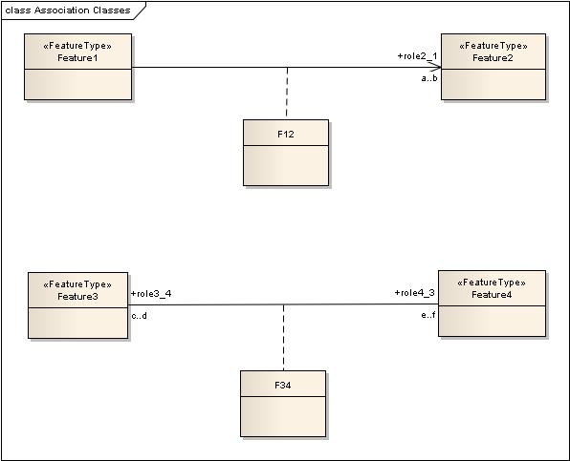
Figure 10b-2 – Model with association classes (from OGC 10-129r1 / ISO 19136-2:2015)
An example (taken from S-127) is shown in Figure 10b-3 below. Here an association class “PermissionType”, corresponding to a relationship with code “Permission”, is used to express the association attribute “categoryOfRelationship”.

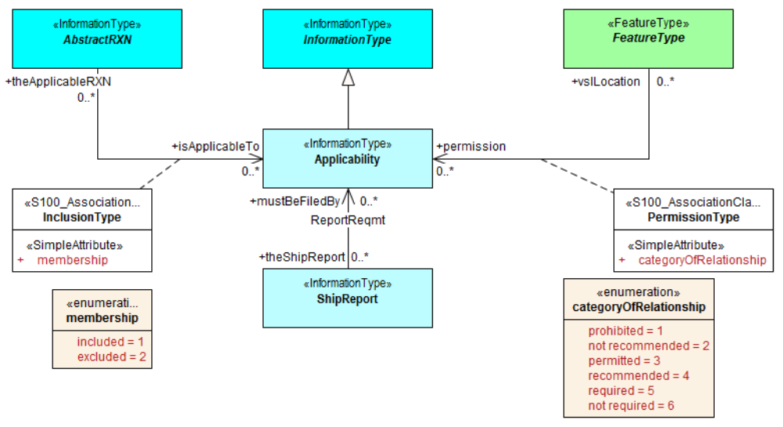
Figure 10b-3 – Example use to represent attributes of associations (S-127)
To avoid needless duplication of relationships between source/destination features and the intermediate information types, the intermediate information type shall be included in line with the referencing feature; for example:
<S-127:VesselTrafficServiceArea gml:id="a1">
<categoryOfCargo>ballast</categoryOfCargo>
<permission xlink:href="#R1">
<S-127:PermissionType gml:id="res1">
<categoryOfRelationship>required</categoryOfRelationship>
</S-127:PermissionType>
</permission>
</S-127:VesselTrafficServiceArea>
<S-127:Applicability gml:id="R1">
<categoryOfCargo code=”7”>dangerous or hazardous</categoryOfCargo>
</S-127:Applicability>
In the Application Schema this shall be done by extension of gmlReferenceType.
<xs:complexType name="PermissionType">
<xs:sequence>
<xs:element name="categoryOfRelationship" type="categoryOfRelationshipType" minOccurs="1" maxOccurs="1"/>
</xs:sequence>
</xs:complexType>
<xs:complexType name="permission">
<xs:complexContent>
<xs:extension base="gml:ReferenceType">
<xs:sequence>
<xs:element name="PermissionType" type="PermissionType" minOccurs="1" maxOccurs="1"/>
</xs:sequence>
</xs:extension>
</xs:complexContent>
</xs:complexType>
The examples above are informative, not mandatory.

S-100 GML data formats
Data formats shall use the camel case codes of features, information types, and attributes and sub-attributes as specified in Feature Catalogues as the ‘local name’ in element tags for GML features and attributes.
EXAMPLE: Given a Feature Catalogue that defines a feature named “Marine Protected Area” with code “MarineProtectedArea”, the corresponding feature in the dataset must use “MarineProtectedArea” as the local name – for example, <S122:MarineProtectedArea ... or <MarineProtectedArea> with the Schema type “MarineProtectedAreaType”
Ordering of elements in GML Schemas corresponding to simple and complex attributes shall be identical with ordering in the Feature Catalogue. Attributes and sub-attributes inherited from abstract types in the Feature Catalogue shall appear before those belonging to the specialised type.
Spatial objects that are encoded independently of features (that is, not embedded inline with a feature) shall be encoded with tags whose local name components are the spatial object elements in the S-100 GML profile (for example, S100:Point).
The GML Profile defines abstract types for feature and information types to be used for definition of concrete types contained in the Feature Catalogue.
Feature and information associations must encode at least one of the role or arcrole attributes of the reference.
The following tags are reserved and may not be used in GML data formats as local names of elements:
- geometry;
- Dataset.
GML data formats for S-100 datasets must follow the GML rules as described in the GML specification (ISO 19136/OGC 07-036), as modified by the S-100 GML profile and this Part.

Processing of GML datasets
Implementations, including applications and production tools, may use any suitable method for processing GML datasets. While GML datasets must conform to the GML Application Schemas defined in Product Specifications, processors are not required to use the GML Application Schemas for processing datasets. However, the combination of the GML specification, this Part, and the S-100 GML profile result in the following commonalities:
- Each dataset has a single root element (“Dataset”). GML datasets are XML documents and this is an XML requirement.
- Given the path /Dataset /X1/X2 then X1 is a feature and X2 is an attribute or association role. Similarly, given /Dataset /X1/X2, X1 is an information type and X2 one of its attributes or associations.
- If X2 has XML attributes xlink:href and xlink:role and/or xlink:arcrole it is an association role.
- If X2 has element content this represents a complex or spatial attribute.
- A spatial attribute or object will have one of the allowed spatial properties as its content.
- If X2 is empty and nilled, or has text or numeric content, it is a simple attribute.
- Applications must allow for the presence or absence of namespaces; for example, X1 might be of the form S122:FeatureA, etc. Namespaces in XML precede a ':' so it is possible for applications to distinguish the namespace part of the tag from the ‘local name’ part.

Spatial types

Geometric primitives
The S-100 GML Profile supports the S-100 implementations of GML 3.2.1 basic geometries (Part 7, clause 7-4.1.1).
For the simplest geometry requirements where no spatial attribution or associations are required, native GML types, imported by the S-100 GML Profile Schemas, and representing S-100 point, curve and surface geometry can be used. These implement equivalents to point, curve and surface geometry defined as geometric primitives in Feature Catalogues.
- GM_Point
- GM_Curve
- GM_Surface
More complex Schemas requiring referencing and spatial attributes (and more complex curve interpolations) can make use of the more complex constructions defined specifically for the S-100 GML Profile;.for example:
- S100_Point
- S100_Curve
  - AbstractCurve
  - OrientableCurve
  - LineStringSegment
  - LineString
  - S100_ArcByCenterPoint
  - S100_CircleByCenterPoint
- S100_Surface
The S-100 GML Profile constrains the GM_CurveInterpolation type values and constrains the curve encoding to a subset of GML curve geometries.
Note: S100_ArcByCenterPoint and S100_CircleByCenterPoint are not the same as the GML primitives ArcByCenterPoint and CircleByCenterPoint.

Curve Interpolation
The list of allowable values consists of a subset of the values allowed by ISO 19136 plus extensions for spline and interpolated curve segments (ISO/DIS 19107 draft – June 2018, clarifies that the list of interpolations in the standard is not exhaustive):
- Linear (linear) in a non-geographic CRS – the interpolation is defined by a series of DirectPositions on a straight line between each consecutive pair of controlPoints.
- Linear interpolation (linear) in a geographic CRS (interpreted as Loxodromic) – the interpolation method shall return DirectPositions on a loxodromic curve between each consecutive pair of controlPoints. A loxodrome is a line crossing all meridians at the same angle, that is, a path of constant bearing.
- Geodesic (geodesic) – the interpolation mechanism shall return DirectPositions on a geodesic curve between each consecutive pair of controlPoints. A geodesic curve is a curve of shortest length. The geodesic shall be determined in the coordinate reference system of the GM_Curve in which the GM_CurveSegment is used.
- Circular arc by 3 points (circularArc3Points) – the interpolation is defined by a series of 3 DirectPositions on a circular arc passing from the start point through the middle point to the end point for each set of three consecutive control points. The middle point is located halfway between the start and end point.
- Elliptical arc (elliptical) – for each set of four consecutive controlPoints, the interpolation mechanism shall return DirectPositions on an elliptical arc passing from the first controlPoint through the middle controlPoints in order to the fourth controlPoint. Note: if the four controlPoints are co-linear, the arc becomes a straight line. If the four controlPoints are on the same circle, the arc becomes a circular one.
- Conic arc (conic) – the same as elliptical arc but using five consecutive points to determina a conic section.
- Circular arc with centre and radius (circularArcCenterPointWithRadius) – the interpolation is defined by an arc of a circle of the specified radius centred at the position given by the single control point. The arc starts,at the start angle parameter and extends for the angle given by the angular distance parameter. This interpolation type shall be used only with S100_ArcByCenterPoint and S100_CircleByCenterPoint geometry. The precise semantics of the parameters are defined in Part 7 clause 7-4.2.20 (S100_ArcByCenterPoint).
- Polynomial (polynomialSpline) – the control points are ordered as in a line-string, but they are spanned by a polynomial function. Normally, the degree of continuity is determined by the degree of the polynomials chosen.
- Bézier Spline (bezierSpline) – the data are ordered as in a line string, but they are spanned by a polynomial or spline function defined using the Bézier basis. Normally, the degree of continuity is determined by the degree of the polynomials chosen.
- B-spline (bSpline) – the control points are ordered as in a line string, but they are spanned by a polynomial or rational (quotient of polynomials) spline function defined using the B-spline basis functions (which are piecewise polynomials). The use of a rational function is determined by the Boolean flag "isRational”. If isRational is TRUE then all the DirectPositions associated with the control points are in homogeneous form. Normally, the degree of continuity is determined by the degree of the polynomials chosen.
- Blended parabolic (blendedParabolic) – the control points are ordered as in a line-string, but are spanned by a function that blends segments of parabolic curves defined by triplet sequences of successive data points. Each triplet includes the final two points of its predecessor. Further details of the semantics are provided in Part 7 clause 7-4.2.2.2.

Geometric complex, geometric composites, and geometric aggregates

Geometric complex and geometric composites
The S-100 GML Profile supports the following composite geometries (Part 7 clause 7-4.1.1):
- CompositeCurve.

Geometric aggregates
The S-100 GML Profile supports the aggregate geometry types (Part 7 clause 7-4.1.1):
- MultiPoint

Inline and by-reference encoding
The S-100 GML Profile supports the ability to encode a geometry either inline or by reference where two features share the same instance of a GM_Object (see Part 3 clause 3-6.5.4.5). Where both are specified the GML convention is followed and the inline reference takes priority.

Envelope
The S-100 GML Profile supports the ability to encode an appropriate geometry via bounding box or envelope. The Profile does not constrain the use of the GML implementation of GM_Envelope.

Schema elements for spatial attributes
GML Application Schemas shall name the S100 spatial attribute type as geometry elements using the reserved element name “geometry”. This is for greater interoperability with broader GML tools. Where multiple geometric primitive types are allowed by the Feature Catalogue defining the GML Application Schema these shall be implemented as XML Schema choice elements and not as aggregated types. Geometry elements shall have multiplicity 0..* in the GML Application Schema.
For example:
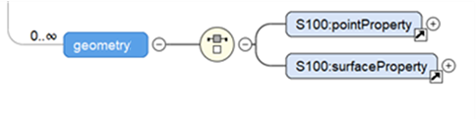

Masking, truncation and scale ranges
The S-100 geometry type has an optional sub-element mask containing those elements which are masked.
Beginning with Edition 5.0.0, the S-100 GML format defines a generic complex type S100_SpatialAttributeType for spatial attributes with scaleMinimum and scaleMaximum attributes and a maskReference tag. These correspond to the attributes of the S100_SpatialAttribute metaclass in the S-100 General Feature Model (Part 3, Figures 3-1 and 3-2 and clause 3-5.3.5). scaleMinimum and scaleMaximum are implemented as integer attributes. The maskReference attribute is implemented using the GML Reference Type with the following constraints:
- The value of the xlink:href attribute must be the gml:id of the masked/truncated object.
- The value of the xlink:role attribute must be either ‘truncated’ or ‘suppressed’.
- The meaning of other attributes is undefined in S-100 and so they are not used within the GML profile.
The structure of the S100_SpatialAttribute Complex type is depicted in Figures 10b-4 and 10b-5 below.
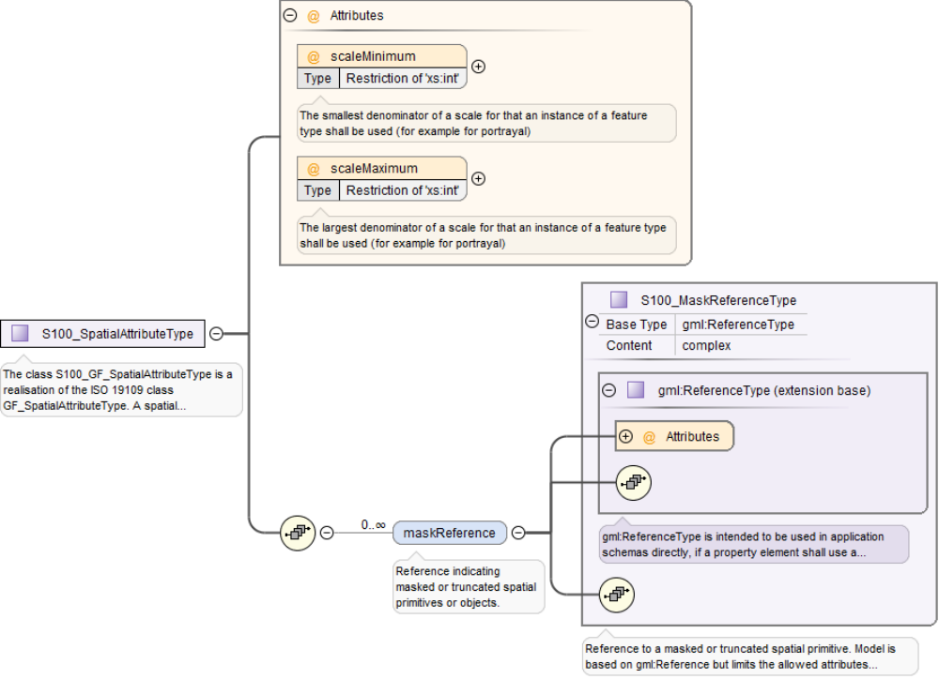
Figure 10b-4 – Structure of generic spatial attribute type in the S-100 GML format
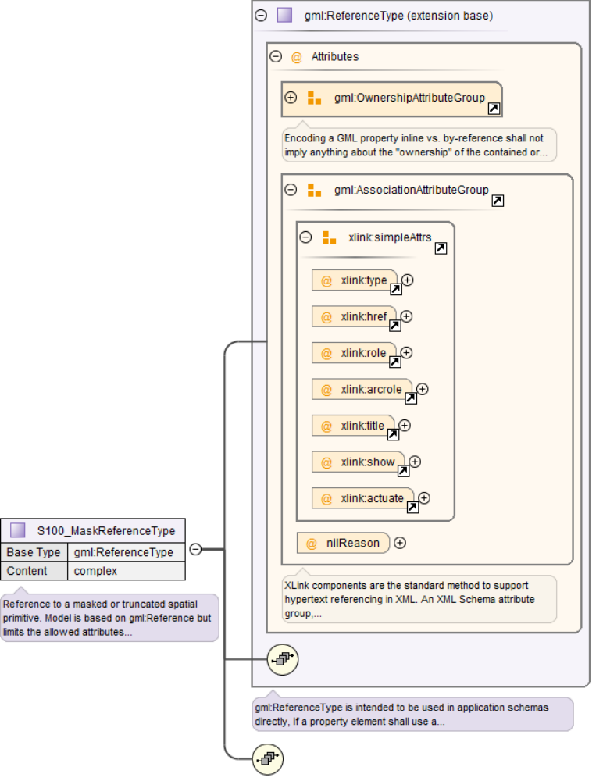
Figure 10b-5 – Structure of mask reference type
NOTE: This Part specifies only the href and role attributes. The other AssociationAttributeGroup members, OwnershipAttributeGroup members, and nilReason are not used.
An example of the use of masking is depicted in Figure 10b-6 below. The surface boundary is defined by reference to two curves (sequential curves comprising the exterior ring), whose gml:id’s are JS.C.123 and JS.C.567. These curves are defined elsewhere in the file. The maskReference tag in the example indicates that the curve JS.C.567 is suppressed.
NOTE 1: The S-100 GML format does not require that the object geometry (the Surface object in Figure X.X) be encoded inline as depicted in Figure X.X. It can be encoded elsewhere in the dataset as a separate spatial data object, like the curves.
NOTE 2: The ‘#’ character preceding the identifier is an XML convention indicating that the part which follows is the identifier of an XML element inside an XML file (since no filename is specified, the convention is that the referenced element is in the same file). Note that the reference mechanism also allows references to objects in external files by prefixing the object identifier with the file name or URL of the external file.
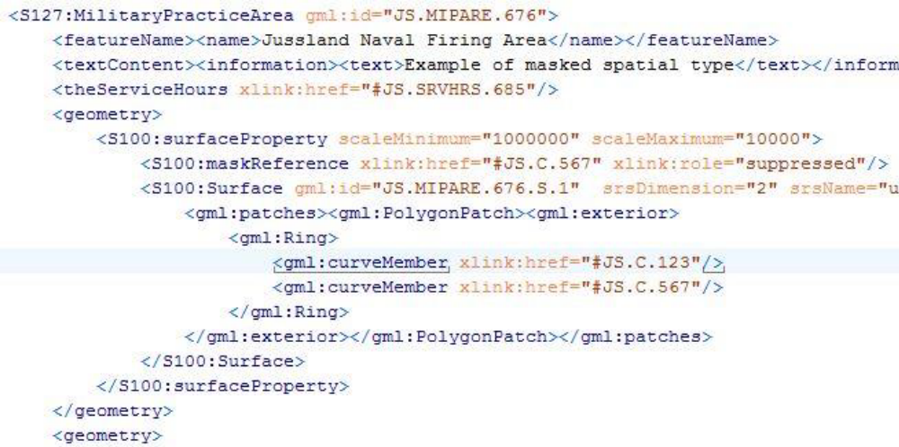
Figure 10b-6 – Example of masking in the GML format

Unsupported GML functionality
Support for GML 3.2.1 and GML 3.3 geometries not defined in ISO 19107 is not included. Specifically, this means CircleByCenterPoint and ArcByCenterPoint (as defined in GML 3.2.1) are not supported, nor are the compact geometry encodings defined in GML 3.3.
The temporal model and temporal primitives defined in ISO 19108, including temporal positions, instants, time periods, are not supported. S-100 data should code dates and times as thematic attributes.
- Dynamic features are not supported by the S-100 GML profile.
- Topology is not supported by the S-100 GML profile.
- Linear Referencing is not supported by the S-100 GML profile.
- Coverages are not supported by the S-100 GML profile.
- The ability to define coordinate reference systems is not supported. The products should be defined using a well-known, pre-defined coordinate reference system such as WGS84.
- Observations are out of scope for the S-100 GML Profile. (The observations schema within GML has been superseded by the OGC (10-025r1) XML encoding for ISO 19156: Observations and Measurements.)

Compliance levels
In order for a client to be able to properly interpret a schema, it needs a capability to identify the compliance level of the application schema. An XML Schema annotation shall be used for this purpose. The following schema fragment shows how this annotation shall be declared in an application schema:
<annotation>
<appinfo>
<gmlProfileSchema xmlns="http://www.opengis.net/gml/3.2">
http://www.iho.int/S-100/profiles/s100_GMLProfile.xsd
</gmlProfileSchema>
<s100:ComplianceLevel>1</s100:ComplianceLevel>
</appinfo>
</annotation>
Table 10b-2 – Compliance declaration XML code
Compliance level | Description
1 | S-100 feature types, information types, feature and information associations. Point, curve, and surface primitives
2 | All features of Level 1, plus circle and arc by center point geometry, splines, and blended interpolations

To manually add the compliance declaration to the schemas after they have been generated involves 3 steps:
- Add the S-100 GML Profile XML Namespace declaration:
xmlns:s100_profile="http://www.iho.int/S-100/profile/s100_gmlProfile"
- Add the S-100 GML Profile compliance declaration within the schema annotation. The compliance declaration is the XML code in Table 10b-2 above.
- Add an Import statement for the S-100 GML Profile Levels schema. Add the following import statement for the S-100 GML Profile Levels schema into the list of imported schemas to the list of imported schemas:
<import namespace="http://www.iho.int/S-100/profile/s100_gmlProfile"
schemaLocation="../../S100/profile/S100_gmlProfileLevels.xsd"/>

S-100 base schema for feature data

Introduction
A second XML Schema is provided which defines a small set of derived types and elements in an “S100” namespace. The Schema defining these common elements and types is technically a “GML Application Schema” in the sense defined by ISO 19136. It defines GML constructs which are expected to be used by different Product Specifications to define detailed GML Application Schemas encoding formats for GML datasets. This Schema provides a common core structural paradigm for GML datasets across a variety of application domains. The intention is to reduce the complexity of application development, facilitate sharing of software modules, and information integration and mapping across different application domains, by minimising the proliferation of structural variations. The XML Schemas are designed to ensure a match between the Feature Catalogue structure and the produced GML Schema.
Elements and types are defined using only the restricted subset of GML defined in the S-100 GML Profile.

Construction of the xsd header
The Application Schema header must define namespaces and prefixes for all imported elements of the S-100 GML Profile. An example top level Schema element is shown below:
<xs:schema
xmlns:xs="http://www.w3.org/2001/XMLSchema"
xmlns:S100="http://www.iho.int/s100gml/1.0"
xmlns:gml="http://www.opengis.net/gml/3.2"
xmlns="http://www.iho.int/S123/gml/1.0"
xmlns:S100EXT="http://www.iho.int/s100gml/1.0+EXT" targetNamespace="http://www.iho.int/S123/gml/1.0"
elementFormDefault="qualified"
version="1.0.0-20170831">
The namespaces defined are:
xmlns:gml=http://www.opengis.net/gml/3.2
xmlns:S100="http://www.iho.int/s100gml/1.0"
xmlns="http://www.iho.int/S123/gml/1.0"
targetNamespace=http://www.iho.int/S123/gml/1.0
elementFormDefault="qualified"
The Schema default namespace and the target namespace are the same and should be formed using a consistent pattern defined in S-100 Part 10b; perhaps based on the Product Specification and the Product Specification version. Using elementFormDefault = ‘qualified’ means every element in the dataset must belong to a namespace but it does not mean that a namespace prefix is needed; a default namespace can be used to set the namespace for any elements without a specific prefix.
NOTE: If the dataset is meant to contain more than one product then no default is used and every element requires a namespace or namespace prefix.

Feature and information types
An XML complex type AbstractFeatureType is defined as the base types for all geographic features in the S-100 profile. Beginning with S-100 Edition 5.0.0 no generic associations are defined within the abstract feature types or information types.
All associations shall be implemented as named associations with names and types corresponding to those used in the source Feature Catalogue. The GML identifier gml:id may shall be used as a default feature identifier.
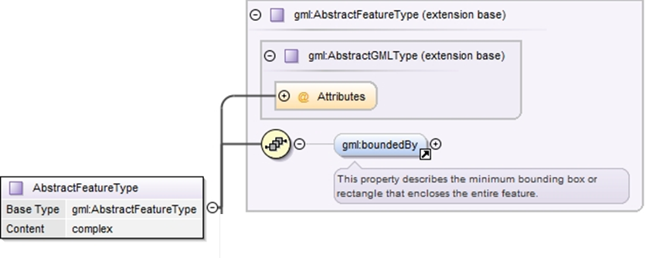
Figure 10b-7 – Base type definition for S-100 feature elements
The common type definition for information types is similar to that for the common feature type.
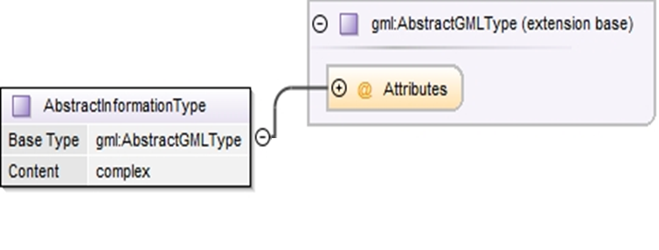
Figure 10b-8 – Base type definition for S-100 information type elements

Spatial types
More complex spatial types are defined as extensions of the corresponding GML spatial types with an information association added, since in S-100 spatial objects can have information associations. The Figure below shows the design of the Point type in the S-100 schema. It includes a single gml:Point type and 0 or more associations to S-100 information types.
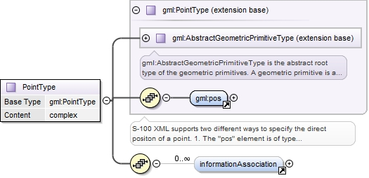
Figure 10b-9 – S-100 generic S-100 spatial type for point spatial object
The other spatial types have a similar structure.

Inline and referenced geometry
The base schema also allows geometry to be defined either inline or by reference, conforming with the same ability in GML. Where both are included in a dataset, the inline geometry is normative.

Spatial types defined in base schema
The base schema defines the point, curve, and surface spatial objects, as well as multipoint and composite curve objects. Curves may be simple, composite, or orientable curves. This is the same set defined in the S-100 GML profile (clause 10b-10.1). It also supports gml:Polygon (ISO 19136) which is a special surface that is defined by a single surface patch.
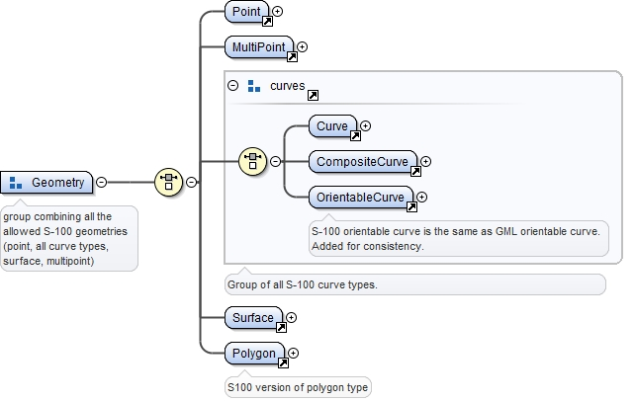
Figure 10b-10 – Geometry types defined in the base schema

Associations
Feature and information association properties are defined as extensions of GML feature properties. The pointers to the object at the other end of the association are encoded in the Xlink attributes.
XLink components are the standard method to support hypertext referencing in XML.
GML provides an XML Schema attribute group, gml:AssociationAttributeGroup, to support the use of Xlinks as the method for indicating the value of a property by reference in a uniform manner in GML. This structure shall be used to encode all associations in the associated Feature Catalogue.
ISO 19136 specifies that the value of a GML property that carries an xlink:href attribute is the resource returned by traversing the link.
The data types of the attributes are listed in the Table below.
Table 10b-3 – Requirements for XLink attributes in associations
Xlink attribute | Data type | Remarks
href | URI | Reference to the object at the other end of the association, for example, the gml:id of an object in the current data set. May be a URI fragment.as described in the XLink specification
role | URI | Optional description of the nature of the target resource, given as a URI
arcrole | legacy extended IRI | Description of the role or purpose of the target resource in relation to the present resource, given as a URI (ISO 19136). May be constructed from the role name from the application schema.  The XLink 1.1 specification requires:  1) The value must be a Legacy extended IRI  2) The identifier must not be relative
title | character string | Optional string describing the relationship. Product specifications may constrain its format and define its semantics
show |  | not used
actuate |  | not used
type |  | not used

Beginning with S-100 Edition 5.0.0, Application Schemas may only use named reference types for associations between features and information types, using the role name as a property element, with generic associations deprecated for use in GML Application Schemas.

Role name as property element
The roles defined in the Application Schema shall be used as the property element of the feature or information type with XLink attributes providing the reference to the instance. In this case the role at the far end of the association should be used for the XML tag defining the property. The role name may be usable as-is for the property tag, or it may have to be mapped to a tag conforming to XML and GML conventions.
Example (non-normative): Given an Application Schema containing the relationship in the figure below, the NavigationLine feature can encode the association as a property element named navTrack as below. The format, construction rules, and semantics for the arcrole and title values would be defined in the Application Scheme.
<NavigationLine gml:id=”US123098”>
<navTrack xlink:href=”#US890321”
xlink:arcrole=”urn:iho:s101:1.0:52.2” title=”RangeSystem”/>
...
</NavigationLine>

and elsewhere in the same file:
<RecommendedTrack gml:id=”US890321”>
<navLine xlink:href=”#US123098”
xlink:arcrole=”urn:iho:s101:1.0:52.1” title=”RangeSystem”/>
...
</RecommendedTrack>

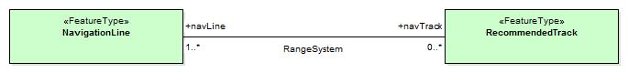
Figure 10b-11 – Association in Application Schema

Updating
Datasets may have two purposes.
- Base datasets containing all features, information types and associations within a specific coverage area, for a given dataset issue date.
- Numbered update datasets, containing only updates to individual features within an earlier base dataset.
Updates are numbered, with a sequential update number, starting at 1, listed in the dataset metadata. A dataset’s purpose is listed in the dataset metadata element and in the catalogue metadata for the exchange set in which it is contained.
Updates are only defined at a feature or information type level. They can only add new features or replace earlier definitions of individual dataset features. Updated features shall retain the GML identifier issued in the base dataset. It is not possible to update associations except by replacing all features affected by a change to references. It is not possible to delete features through update.

Dataset general information

Dataset identification
Dataset identification information is defined by the complex type DatasetIdentificationType. The fields are shown in Table 10b-4 and Figure 10b-12 below.
Table 10b-4 – Dataset identification header elements
Field | XML Tag | Value | Mult. | Type | Description
Encoding specification | encodingSpecification | ‘S-100 Part 10b’ | 1 | CharacterString | Encoding specification that defines the encoding
Encoding specification edition | encodingSpecificationEdition | “1.0” | 1 | CharacterString | Edition of the encoding specification
Product identifier | productIdentifier |  | 1 | CharacterString | Unique identifier for the data product
Product edition | productEdition |  | 1 | CharacterString | Edition of the product specification
Application profile | applicationProfile |  | 1 | CharacterString | “1” – base datasets  “2” – update datasets
Dataset file identifier | datasetFileIdentifier |  | 1 | CharacterString | The file name including the extension but excluding any path information
Dataset title | datasetTitle |  | 1 | CharacterString | The title of the dataset
Dataset reference date | datasetReferenceDate |  | 1 | date | The issue date of the dataset.  Format: YYYY-MM-DD
Dataset language | datasetLanguage | “ENG” | 1 | ISO 639-1-2/T | The (primary) language used in this dataset  3 character codes
Dataset abstract | datasetAbstract |  | 0..1 | CharacterString | The abstract of the dataset
Dataset topic category | datasetTopicCategory | {14}{18} | 1..* | MD_TopicCategoryCode (ISO 19115-1) | A set of topic category codes from the MD_TopicCategoryCode list in ISO 19115-1 (except “extraTerrestrial”)
Dataset Purpose | datasetPurpose | {“Base”,”Update”} | 1 | CharacterString | Whether dataset consists of updated features or all features
Update Number | updateNumber |  | 1 | Integer | The sequential update number of this dataset

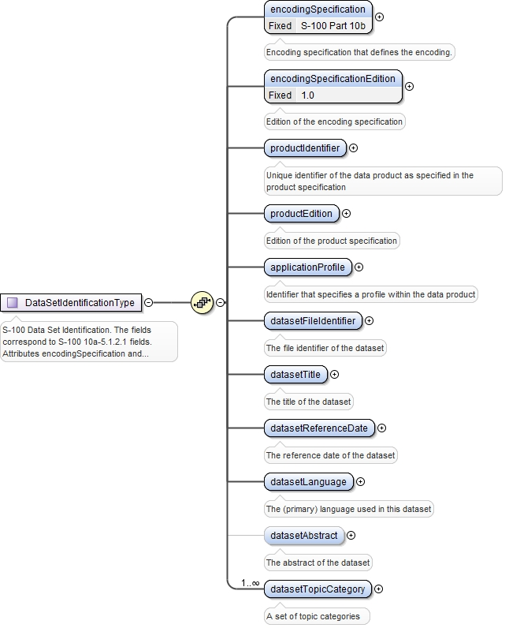
Figure 10b-12 – Dataset identification

Coordinate Reference System
GML allows the coordinate reference system (“spatial reference system”) used for geometry to be determined in different ways – by explicit specification, or by “inheriting” the SRS of outer elements. For S-100 datasets, this means the SRS can be specified in one of two ways:
- Using the srsName attribute of the gml:Envelope element in a feature collection implies that the same SRS is uses for all geometries contained in that collection.
- Using the srsName and srsDimension attributes for individual geometry elements.
Application data formats may use either method, but shall ensure that the SRS of every instance of geometry in a dataset can be determined by application software, using one method or another.
“Standard” geodetic coordinate reference systems shall be identified using the URI convention for SRS specified by OGC.
EXAMPLE http://www.opengis.net/def/crs/EPSG/0/4326

Dataset structure definition
Application Schemas for data products shall define an XML type and element to serve as the root element of a GML dataset, consisting of a collection of XML elements for feature, information type, and spatial data objects defined elsewhere in the Application Schema. This shall be called “Dataset”.

Dataset metadata
The dataset class may contain one or metadata properties to encode dataset level metadata (for example ISO 19115/19139) either inline or by reference.

Constraints and validation
Some validation of data can be done using validating XML processors if the data product’s GML application schema created well defined types wherever possible, for example, enumerated types for the enumeration attributes, and maximum and minimum allowed values for real attributes. However, complete validation, especially of conditional attributes, is likely to require an additional means of data validation.
Constraints allow complex business rules to be defined that restrict the allowable values based on well-defined limits or relationships between properties (for example the end date must be equal to or greater than the start time).
Constraints can be defined in many different ways - human readable text only, object constraint language (OCL), Semantics of Business Vocabulary and Business Rules (SVBR) and these can be documented as part of the UML model or external to the model.
The S-100 GML Profile does not provide explicit support for expressing constraints or for rule-based validation. Current industry best practice, advocates the uses of Schematron to validate XML files based against business rules defined using OCL, SVBR or human readable text. Schematron (ISO/IEC 19757-3) is a rule-based validation language for making assertions about the presence or absence of patterns in XML. Constraints encoded using Schematron may be directly encoded within the resulting Application Schema or may be defined in an associated Schematron document.

Dataset level metadata and integrity checks
The S-100 GML Profile does not explicitly contain any elements relating to dataset level metadata or integrity checks. S-100 Part 15 includes such provisions.

Schema locations and namespaces
The GML profile and GML application schema for common elements are located at the IHO Geospatial Information (GI) Registry web site. Namespaces and versions are also defined on that site.

Divergences from common GML practices
The GML profile (10b-8) and base schema (10b-11) diverge from common GML practice in the following items:
- Interpretation of missing curve interpolation value (see clause 10b-10.1.2).
- Geometry properties are defined individually instead of using substitution groups. There is no single property which functions as a spatial attribute in all features.

Page intentionally left blank

Appendix 10b-A Application Schema (informative)

[To be added]

Page intentionally left blank

Appendix 10b-B

Use of Profile in GML Application Dataset

(informative)

Introduction
This clause illustrates the use of the GML profile (10b-8) and base schema (10b-11) and a GML application schema (App. 10b-A) for an S-100-based data product and a GML dataset.
[To be added]

Dataset structure in GML application schema
An example of the format of a GML dataset is shown in the Figure below. This dataset defines data objects as information objects, spatial objects or feature objects. It specifies the sequence of objects in the file as information objects first, followed by spatial objects, then features.
[To be added]

Page intentionally left blank

Line breaks and spaces have been added for clarity.

